Activity1:
Change the logo in the following files
1. manifest.json
2. appConfig.js

Before Change:

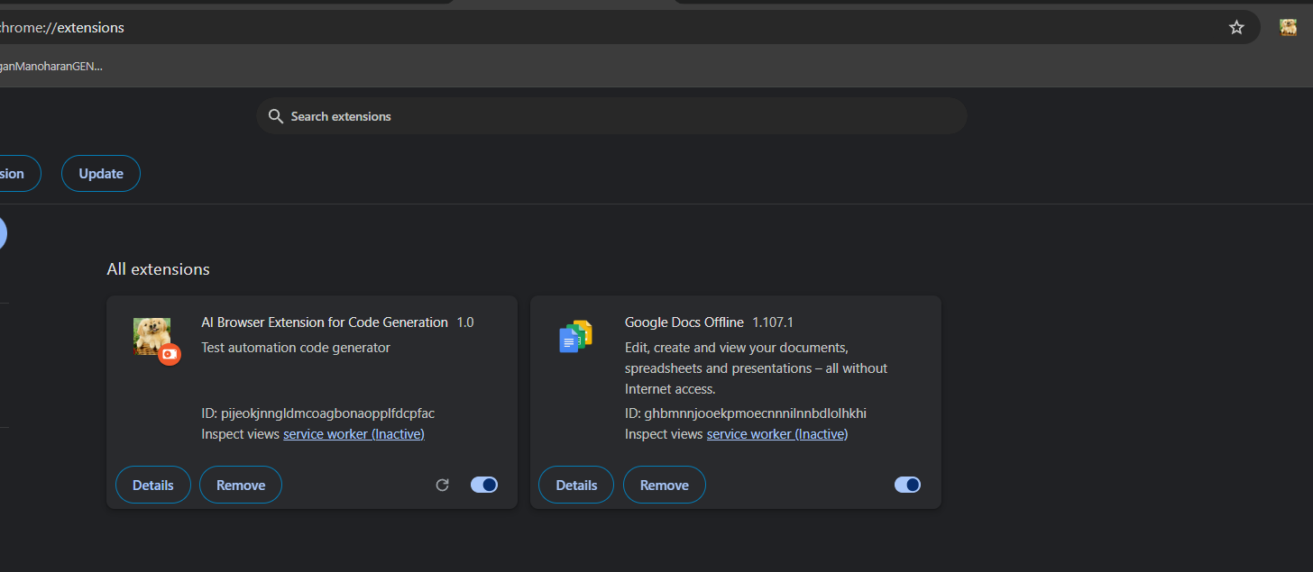

After Change:
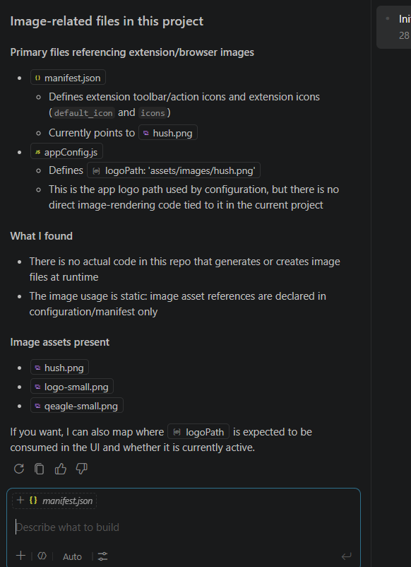
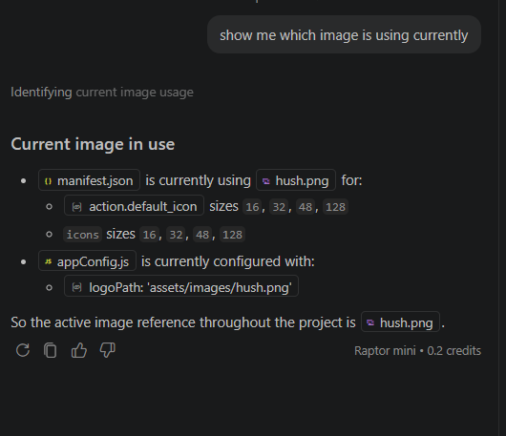
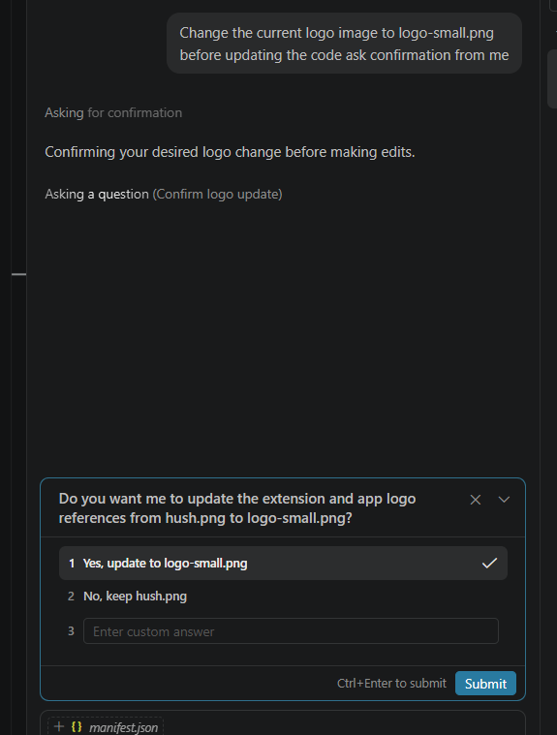
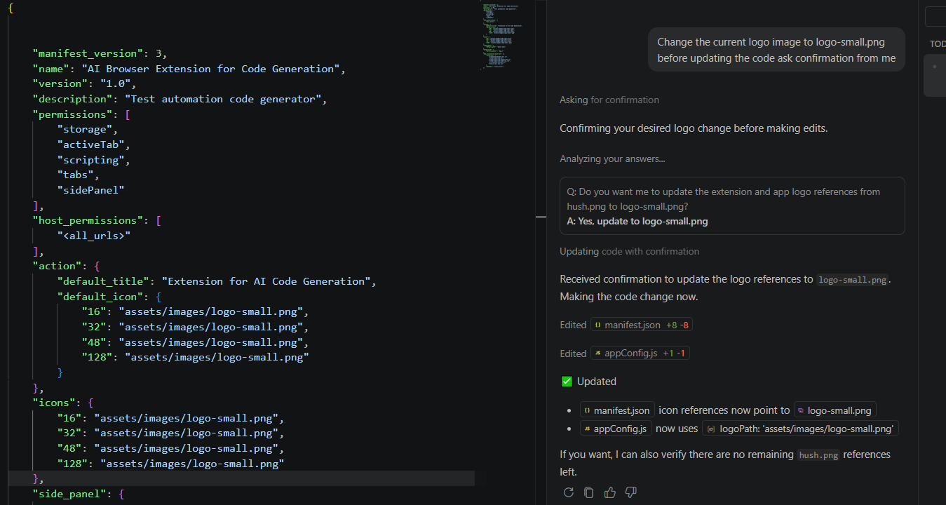
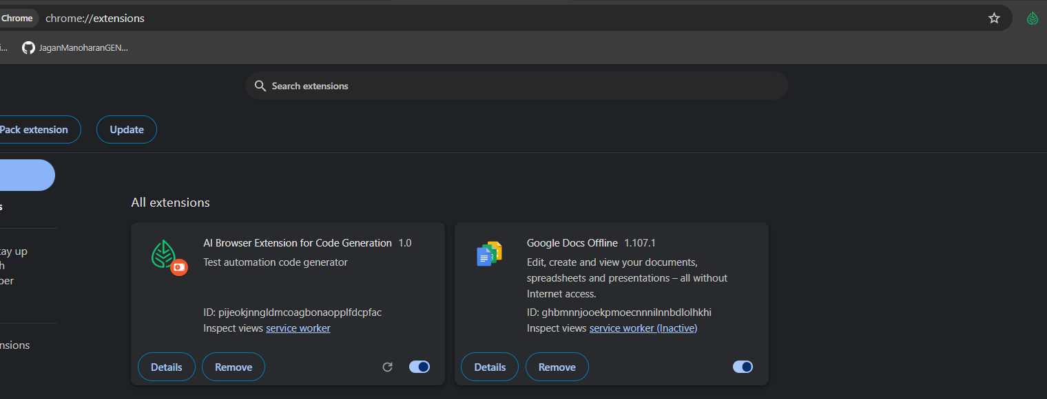

Activity2:
Add "openai/gpt-oss-120b" to the existing list

Before adding Model:
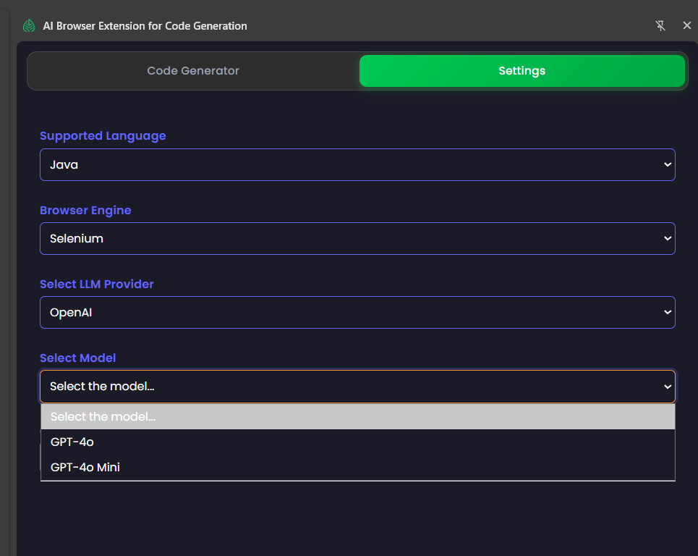

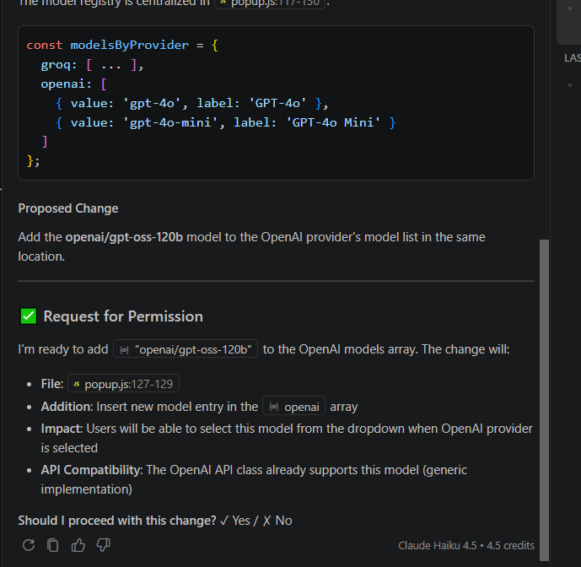
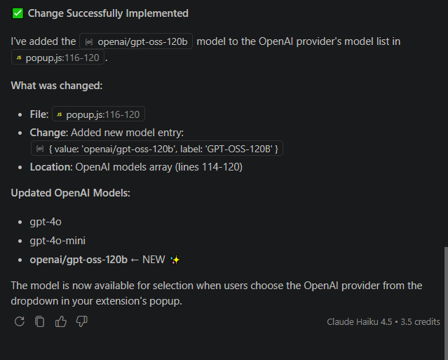After Changer: 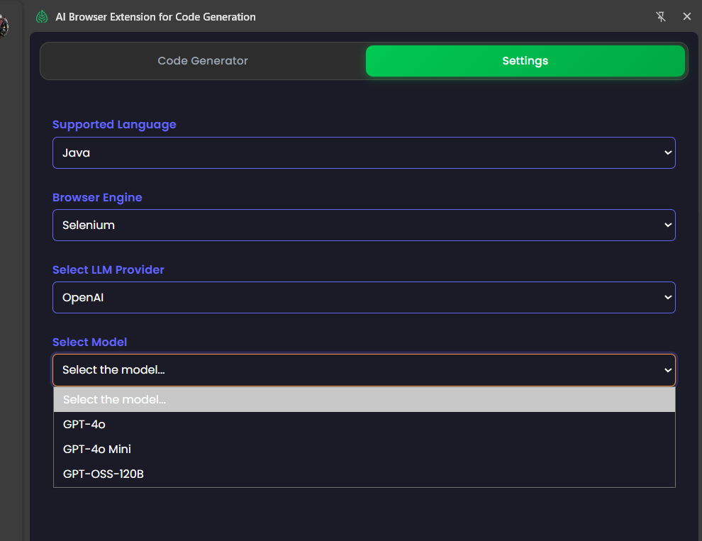
Activity 3:
Implement Playwright with TypeScript
Step1:
Change the mode into Ask
Role: Act as Senior Automation QA
Analyze the existing project structure and identify all files, folders, configurations, and dependencies that will be impacted by implementing Playwright with TypeScript. Provide an impact analysis that includes:
- Files to create
- Files to modify
- Required dependencies
- Configuration changes
- Recommended folder structure
- Any migration risks or assumptions

Do not make any code changes during this step.

Step 2 –
Change the mode into Agent
After completing the analysis, implement the required changes to integrate Playwright with TypeScript. Configure Playwright, TypeScript, package.json, and the project structure following Playwright and Page Object Model (POM) best practices. Reuse existing utilities wherever possible, preserve existing functionality, and ensure the project builds successfully.

Finally, provide a summary of:
- Files created
- Files modified
- Dependencies installed
- Configuration changes
- Validation results

